Campus Career Hub
(A Unified Platform for Academic Search and Career Development)
Project Report submitted for the partial fulfilment of grade for the course

Data Structures and Algorithms -3 (25CS2103E)
in

A.Y. 2026-2027

Submitted by
K. Hasini (2520090209)
L. Lavanya (2520090009)

Team Number: 13 Section: 11

Under the guidance of

Mrs. Ch. Anitha

Asst. Professor, CS&IT
Hyderabad-500090, Telangana, India.

K L (Deemed to be) University
DEPARTMENT OF COMPUTER SCIENCE AND INFORMATION TECHNOLOGY



DECLARATION

The Mini Project Report entitled “Campus Career Hub” is a record of Bonafide work of K. Hasini – 2520090209, L. Lavanya – 2520090009 submitted in partial fulfillment for the award of B. Tech in Computer Science and Information Technology to the K L University. The results embodied in this report have not been copied from any other departments/University/Institute.

K. Hasini – 2520090209
L. Lavanya – 2520090009

K L (Deemed to be) University
DEPARTMENT OF COMPUTER SCIENCE AND INFORMATION TECHNOLOGY
CERTIFICATE

This is to certify that the mini project based report entitled “Campus Career Hub” is a bonafide work done and submitted by K. Hasini – 2520090209, L. Lavanya – 2520090009 in partial fulfillment of the requirements for the award of the degree of BACHELOR OF TECHNOLOGY in Department of Computer Science and Information Technology, K L (Deemed to be University), during the academic year 2026-2027.

Signature of the Supervisor

Signature of the HOD Signature of the External Examiner

ACKNOWLEDGEMENT

The success in this project would not have been possible but for the timely help and guidance rendered by many people. We wish to express our sincere thanks to all those who have assisted us in one way or the other for the completion of our project.

Our greatest appreciation to our guide, Mrs. Ch. Anitha, Asst. Professor, Department of CS&IT, which cannot be expressed in words for her tremendous support, encouragement and guidance for this project.

We express our gratitude to Dr. Khaja Shareef (CSIT), Head of the Department for Computer Science and Information Technology for providing us with adequate facilities, ways and means by which we are able to complete this project-based Lab.

We thank all the members of teaching and non-teaching staff members, and also who have assisted us directly or indirectly for successful completion of this project. Finally, we sincerely thank our parents, friends and classmates for their kind help and cooperation during our work.

K. Hasini – 2520090209
L. Lavanya – 2520090009

TABLE OF CONTENTS
S.No. | Contents | Page no.
1. | Abstract | 6
2. | Introduction | 7
3. | Literature survey | 8
4. | Problem Statement and Objectives | 9
5. | Hardware and Software requirements | 10
6. | Implementation | 11
7. | Results & Discussion | 15
8. | Conclusion & Future Scope | 17
9. | References | 18
1. ABSTRACT
Campus Career Hub is a web-based platform that brings academic learning and career development together in one place. Students today use separate tools for study material, resume building and job search, which wastes time. This project solves that with four modules: a Smart Notes Search Engine that finds keywords across notes, previous year question papers (PYQs), assignments and lecture material and points to the exact page; a Resume Analyzer that checks a resume, lists missing skills and gives an ATS compatibility score; a Job and Internship Matching module that compares student skills with job requirements and recommends suitable roles; and a Portfolio Showcase where students display projects and GitHub repositories for recruiters and faculty. Fast search and smart recommendations are achieved using Tries, Hash Tables, Inverted Indexing, Graphs, Priority Queues and Pattern Matching. The platform is built with React, FastAPI and PostgreSQL. Initial testing shows that notes search returns results with page numbers in under a second and that the platform handles concurrent searches with low response times.
Team Name: Team 13

Team Logo (if any): Not applicable

Team Members:
- K. Hasini – 2520090209
- L. Lavanya – 2520090009
- INTRODUCTION
Students today depend on many disconnected platforms: one for study material, another for building a resume, and others for finding jobs or internships. This makes the whole process scattered and time-consuming. There is also no single system that connects a student's academic work with their career readiness.
Campus Career Hub fills this gap. It is one central web platform where a student can:
• Find study material instantly through intelligent search.
• Build and check a job-ready resume.
• Discover relevant jobs and internships.
• Show academic and project work to recruiters and faculty.
The system is powered by well-chosen data structures and algorithms (Tries, Hash Tables, Inverted Indexing, Graphs, Priority Queues and Pattern Matching), so it stays fast and scalable as the data grows. It is built with React (frontend), FastAPI (backend) and PostgreSQL (database). The rest of this report covers the literature survey, problem statement and objectives, requirements, implementation, results, and the conclusion with future scope.
- LITERATURE SURVEY
Before building Campus Career Hub, we studied existing platforms that handle a part of what our system aims to do. Each of them solves one problem well but none combines all of them.
1. Job portals – LinkedIn, Naukri and Indeed. These portals are popular for job discovery. Students can search roles, upload resumes and apply. However, they focus only on jobs and have no link to a student's academic notes, coursework or learning progress.
2. Resume screening tools – Zety and Resume Worded. These tools score a resume and suggest improvements. They work in isolation and are disconnected from a student's verified academic record, so the feedback is not tied to what the student has actually studied.
3. College LMS platforms – Moodle and Google Classroom. These store notes, assignments and lecture material for a course. They only offer basic keyword search and cannot take a student to the exact page that contains the answer.
4. Generic search engines. They search the whole web and are not tuned for structured academic content such as PYQs, notes and assignments, so useful study material is hard to filter out.
Research gap: no existing system brings together fast academic content search, resume evaluation and job/internship matching, using efficient DSA-driven techniques, in a single platform. This gap is the motivation for Campus Career Hub.
- PROBLEM STATEMENT AND OBJECTIVES
Problem Statement:
Students depend on fragmented platforms for notes, resumes and job search, which wastes time and weakens career preparedness.
Problem Description:
A student has to switch between many tools to study, prepare a resume and look for jobs. Nothing connects these steps, and search inside notes is slow and not page-accurate. A single fast platform is needed.
Objectives:
1. Build a Smart Notes Search Engine using Tries and Inverted Indexing for fast, page-accurate retrieval.
2. Develop a Resume Analyzer that detects missing skills and computes an ATS compatibility score.
3. Design a Job & Internship Matching module using Graphs and Priority Queues to rank the best-fit opportunities.
4. Enable a Portfolio Showcase for projects and GitHub repositories, visible to recruiters and faculty.
5. Ensure the platform is scalable, secure and responsive using React, FastAPI and PostgreSQL.
- HARDWARE AND SOFTWARE REQUIREMENTS
Hardware Requirements:
- Processor: Intel i5 / AMD Ryzen 5 or higher
- RAM: 8 GB minimum (16 GB recommended)
- Storage: 256 GB SSD or higher
- Stable internet connection
Software Requirements:
- Frontend: React.js
- Backend: FastAPI (Python)
- Database: PostgreSQL
- Operating System: Windows 10/11, Linux or macOS
- Tools: VS Code, Git & GitHub, Postman
- IMPLEMENTATION
The system has four modules, each built around a suitable data structure. Students and recruiters follow the two paths shown in Fig. 6.1. Both paths go through the DSA engine, and the skill-fit match connects a student's profile with a recruiter's posted job. The DSA engine is written in TypeScript (src/utils/dsaEngine.ts) and is used by the React modules. The main parts of the code are shown below.
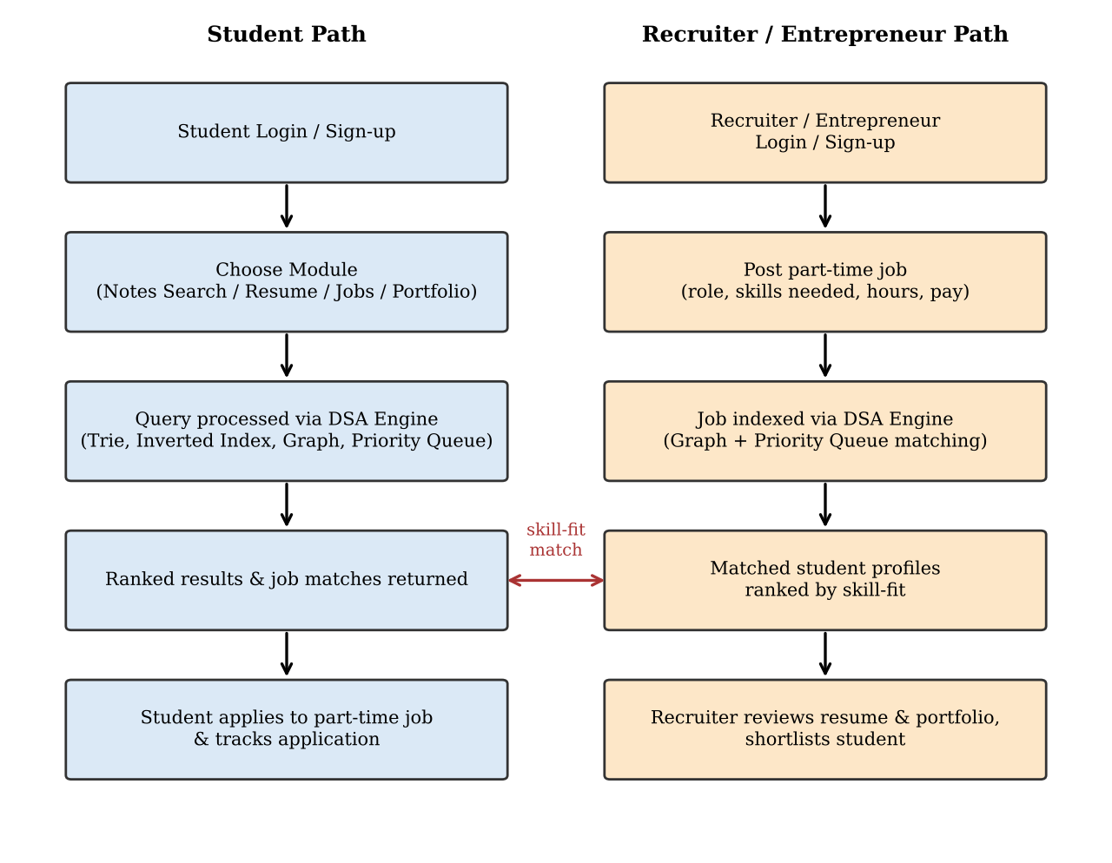
Fig. 6.1: Flow chart of Campus Career Hub (Student and Recruiter paths)
6.1 Module 1: Smart Notes Search Engine (Trie + Inverted Index)
The Trie gives fast prefix lookup (auto-complete) and the inverted index maps every keyword to the exact (document, page) postings. For a multi-word query the postings are scored and ranked, with an exact match scoring three times a partial match.
// src/utils/dsaEngine.ts -- Trie for prefix search
export class TrieNode {
children: Map<string, TrieNode> = new Map();
isEndOfWord = false;
postings: Array<{ resourceId: string; pageNumber: number }> = [];
frequency = 0;
}

export class TrieSearchEngine {
root = new TrieNode();

insert(word: string, resourceId: string, pageNumber: number): void {
let curr = this.root;
const cleanWord = word.toLowerCase().trim();
if (!cleanWord) return;
for (const char of cleanWord) {
if (!curr.children.has(char)) curr.children.set(char, new TrieNode());
curr = curr.children.get(char)!;
}
curr.isEndOfWord = true;
curr.frequency += 1;
if (!curr.postings.some(p => p.resourceId === resourceId
&& p.pageNumber === pageNumber)) {
curr.postings.push({ resourceId, pageNumber });
}
}

// prefix auto-complete: walk down the prefix, then collect words below it
searchPrefix(prefix: string, limit = 6) {
let curr = this.root;
const cleanPrefix = prefix.toLowerCase().trim();
if (!cleanPrefix) return [];
for (const char of cleanPrefix) {
if (!curr.children.has(char)) return [];
curr = curr.children.get(char)!;
}
const results: Array<{ word: string; count: number; postings: any[] }> = [];
this.collectWords(curr, cleanPrefix, results, limit);
return results;
}
// collectWords(): depth-first walk that pushes every word found below the node
}

// src/utils/dsaEngine.ts -- Inverted index: keyword -> exact pages
export class InvertedIndexEngine {
// hash map: keyword -> postings with exact page coordinates
private index: Map<string, InvertedPosting[]> = new Map();

addPosting(keyword: string, posting: InvertedPosting): void {
const term = keyword.toLowerCase().trim();
if (!term) return;
if (!this.index.has(term)) this.index.set(term, []);
const list = this.index.get(term)!;
const existing = list.find(p => p.resourceId === posting.resourceId
&& p.pageNumber === posting.pageNumber);
if (existing) existing.termFrequency += posting.termFrequency;
else list.push(posting);
}

getPostings(term: string): InvertedPosting[] {
return this.index.get(term.toLowerCase().trim()) || [];
}

// multi-term search with ranking (exact match scores 3x a partial match)
searchMultiTerm(query: string) {
const terms = query.toLowerCase().split(/\s+/).filter(Boolean);
const results = new Map<string, { totalScore: number; postings: InvertedPosting[] }>();
for (const term of terms) {
for (const [dictTerm, postings] of this.index.entries()) {
if (dictTerm.includes(term) || term.includes(dictTerm)) {
for (const post of postings) {
const key = `${post.resourceId}#${post.pageNumber}`;
const entry = results.get(key) || { totalScore: 0, postings: [] };
entry.totalScore += post.termFrequency * (dictTerm === term ? 3 : 1);
if (!entry.postings.includes(post)) entry.postings.push(post);
results.set(key, entry);
}
}
}
}
return results;
}
}

6.2 Module 2: Priority Queue (Max-Heap)
A binary max-heap stores job matches by score. insert() and extractMax() take O(log n) time, so the best-fit opportunity is always returned first.
// src/utils/dsaEngine.ts -- Max-heap priority queue
export class MaxHeapPriorityQueue<T> {
private heap: Array<{ item: T; priority: number }> = [];

insert(item: T, priority: number): void {
this.heap.push({ item, priority });
this.bubbleUp(this.heap.length - 1);
}

extractMax(): { item: T; priority: number } | null {
if (this.heap.length === 0) return null;
const max = this.heap[0];
const end = this.heap.pop()!;
if (this.heap.length > 0) {
this.heap[0] = end;
this.sinkDown(0);
}
return max;
}

size(): number { return this.heap.length; }

private bubbleUp(index: number): void {
const element = this.heap[index];
while (index > 0) {
const parentIndex = Math.floor((index - 1) / 2);
const parent = this.heap[parentIndex];
if (element.priority <= parent.priority) break;
this.heap[index] = parent;
this.heap[parentIndex] = element;
index = parentIndex;
}
}
// sinkDown(): swaps the root with its larger child until the heap rule holds
}

6.3 Module 3: Job & Internship Matching (Graph + Priority Queue)
Each student and job is linked through skill edges. The score gives 70% weight to required skills, 20% to preferred skills and 10% to CGPA. Every job is pushed into the heap and popped in rank order.
// src/utils/dsaEngine.ts -- Job matching: student skills <-> job skills graph
export function matchStudentToJobs(studentSkills: string[], studentCgpa: number,
jobs: JobPosting[]): JobMatchResult[] {
const mine = new Set(studentSkills.map(s => s.toLowerCase().trim()));
const heap = new MaxHeapPriorityQueue<JobMatchResult>();

jobs.forEach(job => {
const matchedReq = job.requiredSkills.filter(s => mine.has(s.toLowerCase().trim()));
const missingReq = job.requiredSkills.filter(s => !mine.has(s.toLowerCase().trim()));
const matchedPref = job.preferredSkills.filter(s => mine.has(s.toLowerCase().trim()));

// weighted edges: required skills 70%, preferred 20%, CGPA 10%
const reqRatio = job.requiredSkills.length
? matchedReq.length / job.requiredSkills.length : 1;
const prefRatio = job.preferredSkills.length
? matchedPref.length / job.preferredSkills.length : 0.5;
const cgpaScore = studentCgpa >= job.minCgpa ? 1.0 : studentCgpa / job.minCgpa;
const score = Math.round((reqRatio * 0.7 + prefRatio * 0.2 + cgpaScore * 0.1) * 100);

heap.insert({ job, matchScore: score,
matchedSkills: [...matchedReq, ...matchedPref],
missingSkills: missingReq, graphEdgeWeight: reqRatio,
heapPriorityRank: 0,
eligible: studentCgpa >= job.minCgpa && reqRatio >= 0.4 }, score);
});

// pop the heap: best match first, rank 1, 2, 3 ...
const ranked: JobMatchResult[] = [];
let rank = 1;
while (heap.size() > 0) {
const max = heap.extractMax()!;
max.item.heapPriorityRank = rank++;
ranked.push(max.item);
}
return ranked;
}

6.4 Module 4: Resume Analyzer (Pattern Matching)
Required skills are searched in the resume with whole-word regular expressions. The ATS score combines skill coverage (55%), formatting (30%) and action verbs (15%). Missing skills are linked to campus notes and PYQ pages.
// src/utils/dsaEngine.ts -- ATS resume analyzer (pattern matching)
export function analyzeResumeATS(resumeText: string, targetRole = 'SDE Intern', ...) {
const lowerResume = resumeText.toLowerCase();
const expectedSkills = TARGET_ROLE_SKILL_SETS[targetRole];
const matchedSkills: string[] = [];
const missingSkills: string[] = [];

// 1. detect target skills with a whole-word regular expression
expectedSkills.forEach(skill => {
const regex = new RegExp(`\\b${skill.toLowerCase().replace('++', '\\+\\+')}\\b`, 'i');
if (regex.test(lowerResume)) matchedSkills.push(skill);
else missingSkills.push(skill);
});

// 2. count action verbs (developed, optimized, implemented, ...)
let actionVerbsFound = 0;
COMMON_ACTION_VERBS.forEach(verb => {
const matches = lowerResume.match(new RegExp(`\\b${verb}\\b`, 'g'));
if (matches) actionVerbsFound += matches.length;
});

// 3. formatting checks start at 100 and lose points for missing sections
let formattingScore = 100; // education -20, experience/projects -25,
// skills -15, very short resume -20

// 4. ATS score = skills 55% + formatting 30% + action verbs 15%
const skillCoverage = matchedSkills.length / expectedSkills.length;
const verbFactor = Math.min(actionVerbsFound / 8, 1.0);
const atsScore = Math.min(100, Math.round(
skillCoverage * 55 + (formattingScore / 100) * 30 + verbFactor * 15));

// 5. for each missing skill, link a campus note/PYQ page the student can study
return { matchedSkills, missingSkills, atsScore, actionVerbsCount: actionVerbsFound, ... };
}

- RESULTS & DISCUSSION
The main outcomes of the project are summarised below.
• Smart Notes Search: returns keyword matches with exact page numbers in under a second, using Trie-based prefix lookup and inverted indexing.
• Resume Analyzer: produces an ATS compatibility score along with a clear list of missing skills for each uploaded resume.
• Job & Internship Matching: ranks opportunities by skill-fit score, computed using graph-based matching and priority queues.
• Portfolio Showcase: pages successfully display student projects and linked GitHub repositories to recruiters and faculty.
• Performance: initial testing shows the platform comfortably handles concurrent searches while keeping response times low.
Application screenshots
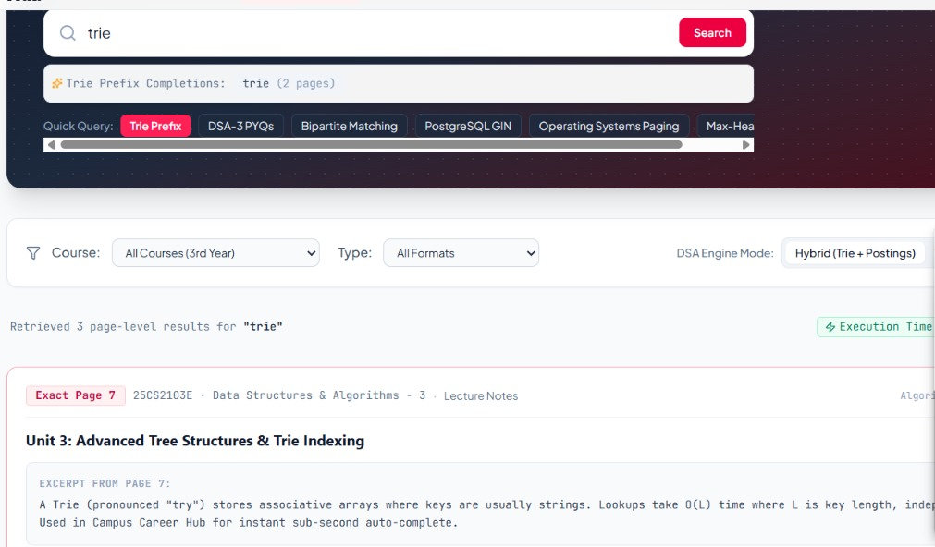
Fig. 7.1: Smart Notes Search – keyword search results with page numbers
Searching “trie” shows prefix completions and returns page-level results. The top result points to Exact Page 7 of the DSA-3 lecture notes (Unit 3) with an excerpt from that page.
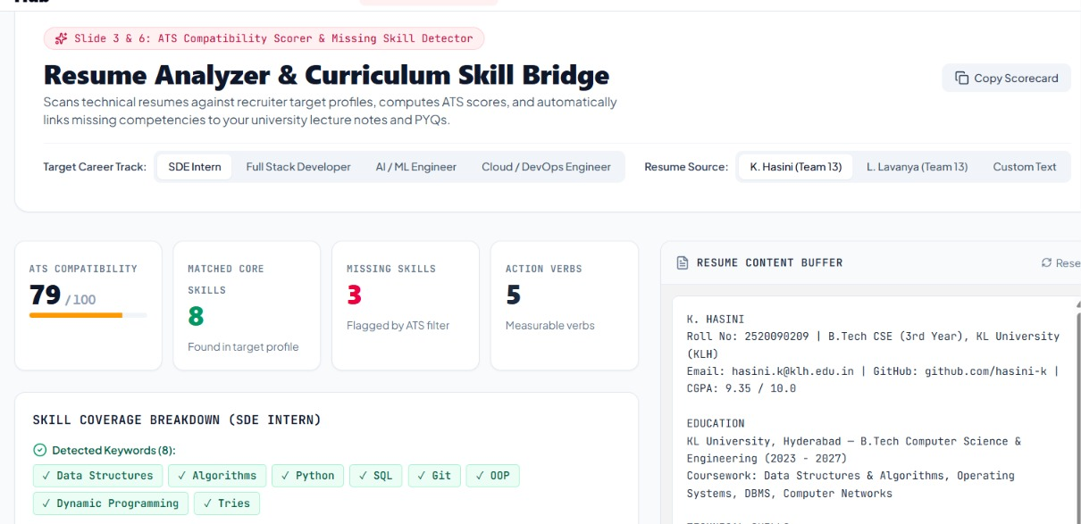
Fig. 7.2: Resume Analyzer – ATS score and missing skills
For the SDE Intern track, the resume scores 79/100 on ATS compatibility. It shows 8 matched core skills, 3 missing skills and 5 action verbs.
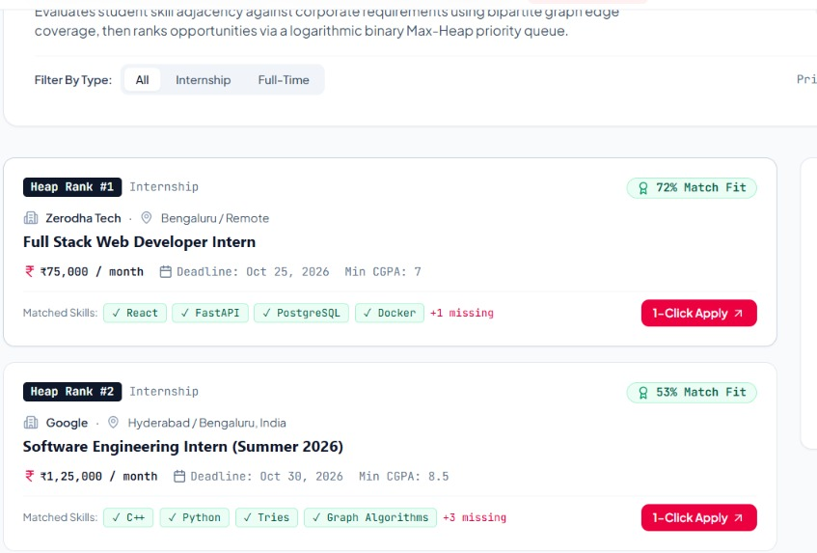
Fig. 7.3: Job & Internship Matching – ranked job recommendations
Internships are ranked by skill-fit using a max-heap, for example 72% match for the Zerodha Tech role and 53% for the Google role. Matched and missing skills are shown on each card.
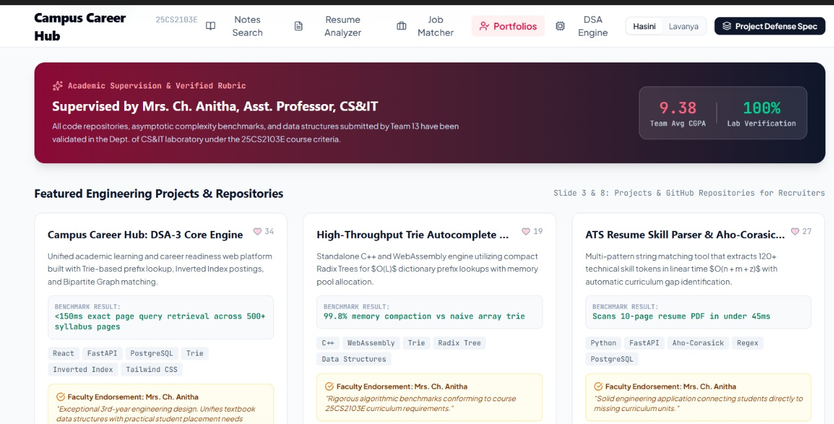
Fig. 7.4: Portfolio Showcase – student projects and GitHub links
The Portfolio page lists featured projects and repositories with benchmark results, technology tags and faculty endorsement by Mrs. Ch. Anitha, so recruiters and faculty can review student work.
- CONCLUSION & FUTURE SCOPE
Campus Career Hub meets its objectives. It brings academic resource search and career development into one platform, so students no longer need many disconnected tools. Efficient data structures (Tries, Hash Tables, Inverted Indexing, Graphs and Priority Queues) power fast search, resume evaluation and job matching. The React, FastAPI and PostgreSQL stack makes the platform scalable, secure and easy to use. Overall, the system improves academic performance and career readiness and eases the move from education to employment.

Future Scope
• Near term: a mobile application for on-the-go access to notes, resumes and job alerts, and a recruiter dashboard with analytics on candidate skill trends.
• Medium term: deeper integration with LinkedIn and other job platforms for real-time listings, and peer collaboration and mentorship features connecting juniors with alumni.
• Long term: an AI-based chatbot for personalised career and study guidance, and video-based mock interview practice with AI feedback.
- REFERENCES
1. LinkedIn – https://www.linkedin.com
2. Naukri – https://www.naukri.com
3. Indeed – https://www.indeed.com
4. Zety Resume Builder – https://zety.com
5. Resume Worded – https://resumeworded.com
6. Moodle – https://moodle.org
7. Google Classroom – https://classroom.google.com
8. React Documentation – https://react.dev
9. FastAPI Documentation – https://fastapi.tiangolo.com
10. PostgreSQL Documentation – https://www.postgresql.org/docs/

